2 Day Desert Yurt Camp Tour from Bukhara
Day 1: Bukhara – Nurata – Yurt Camp
After breakfast in Bukhara, embark on a three-hour drive to Nurata, a town rich in history. Visit the Chashma Complex, known for its sacred spring, explore Nur Fortress, built by Alexander the Great, and admire Juma Mosque. Enjoy a traditional Uzbek lunch before heading on a two-hour drive to a yurt camp in the Kyzylkum Desert. Upon arrival, settle into your traditional yurt, then take a camel ride or enjoy a desert walk. As the sun sets, experience an authentic Uzbek dinner followed by a folk music performance around a campfire under a starlit sky. Spend the night in a peaceful yurt stay, immersed in the silence of the desert.
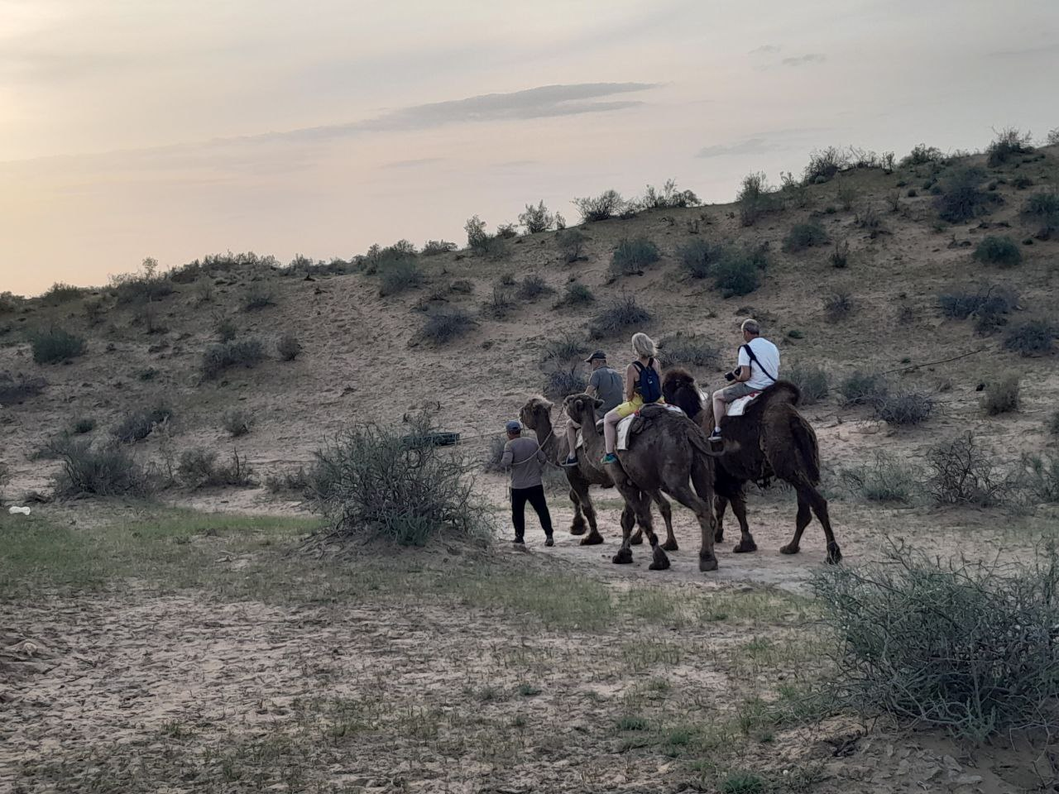

Day 2: Yurt Camp – Lake Aydarkul – Samarkand
Wake up to a desert sunrise and enjoy breakfast before heading to Lake Aydarkul. Spend the morning relaxing by the lake, swimming, or birdwatching, then enjoy a picnic lunch featuring fresh fish. After lunch, drive three hours to Samarkand, arriving in the late afternoon. Check in to your hotel and unwind, or explore the city at your own pace. For dinner, consider a meal at Platan Restaurant, known for its modern Uzbek cuisine. This marks the end of your adventure through Uzbekistan’s deserts, lakes, and historical sites.

Included: -Accomodation -Full board (Breakfast,Lunch and Diner) -Transpotation – tips ?
Per persons 170 euro
DESERT ROSE" option A
Day 1: Samarkand - Nurata - Yurt camp
Pick-up at hotel in Samarkand. Drive to Nurata city. Visit "Chashma" memorial complex and ruins of harnisone of Alexender the Great. Lunch at local’s house. Drive to Yurts Camp. Rest. Try camel riding (no more than 10 min) experience. Dinner at camp. Enjoy singing of Kazakh akyn. Overnight at yurts.
Day 2: Yurt camp - Aydarkul - Bukhara
Breakfast at the yurt camp. Move to the Aydarkul lake shore. Have picnic at lakeside. Drive to Bukhara. Stop at Rabat-i-Malik caravanserai. Visit pottery masters workshop in Gijduvan. End of the services.
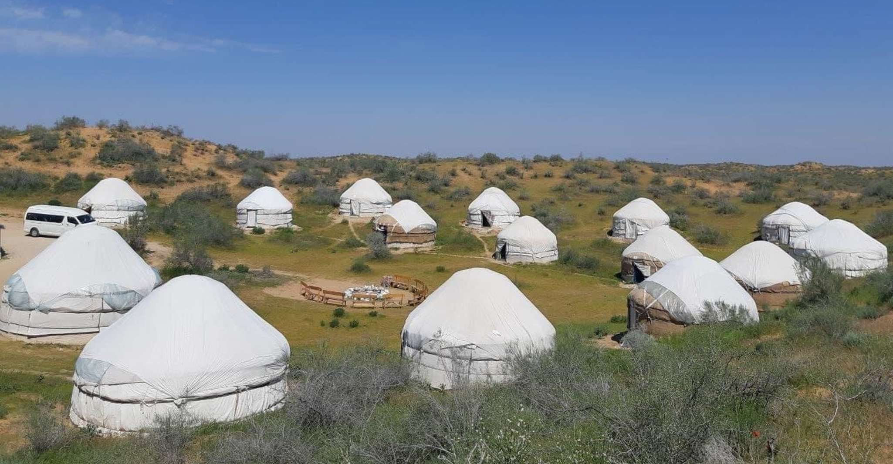
Your 3-Day Rural Homestay in Nuratau Mountain Villages Hayat

4-Day Sentob Village Homestay & Nuratau Mountains Hike
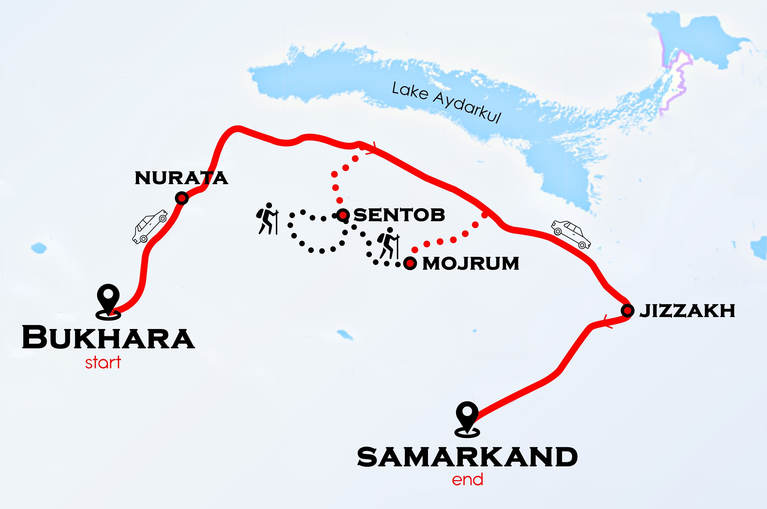
Absolutely! Here’s a paraphrased version of your 4-day Sentob homestay and hiking tour itinerary, keeping all the details but making it more concise and reader-friendly:

4-Day Sentob Homestay & Hiking Adventure
Day 1 – Bukhara → Sentob Village
- Morning: Meet your driver at 9:00 AM and drive to Sentob village.
- Arrival & Lunch: Your host family will welcome you and show you around the homestay, which often features gardens with fruit trees and shaded tapchans. Enjoy a traditional lunch with your hosts.
- Afternoon: Explore the village, visiting the mosque, ancient fortress ruins, and traditional stone houses. Observe local life and interact with friendly villagers as they go about their daily activities.
- Evening: Spend time with your host family, either helping with or watching dinner preparation, and enjoy a relaxing evening immersed in local hospitality.

Day 2 – Sentob Village: Kadvan or Fazilman Hike
- Morning: After breakfast, meet your mountain guide for a full-day hike. Choose between:
  - Kadvan Valley: 15 km / ~7.5 hours
  - Fazilman Plateau: 22 km / ~10 hours
- Hike Highlights: Trek through Sentob Valley past an old watermill, fortress ruins, and Arabic rock inscriptions. Walk along streams, waterfalls, and natural pools. Picnic lunch will be provided.
- Wildlife & Nature: Spot diverse birds, including Spotted Flycatchers, Eurasian Blackbirds, Blue Rock-Thrushes, and more.
- Return: Kadvan hikers return via the same valley; Fazilman hikers descend via Saridash ridge.
Note: Hiking routes may change in spring if river levels are high.

Day 3 – Sentob → Majerum
- Morning Hike: After breakfast, hike 11 km (~3.5–4 hours) to Majerum, passing through the Nuratau Nature Reserve buffer zone. Enjoy scenic views and possible wildlife sightings.
- Homestay Arrival: Stay with Mr. Qoldosh and Ms. Muhabbat Mirzaeva at Muhammad Ali’s homestay, local fruit farmers.
- Afternoon: Explore the reserve with a two-hour hike to the legendary arbor vitae tree, said to be planted by Alexander the Great’s soldiers, and visit a nearby mosque, a local pilgrimage site.
- Evening: Return to your homestay for a hearty dinner and share stories with your hosts.

Day 4 – Majerum → Samarkand
- Morning: Enjoy breakfast and say goodbye to your hosts.
- Transfer: Drive back to Samarkand, concluding your Sentob adventure.

Per persons 270 euro

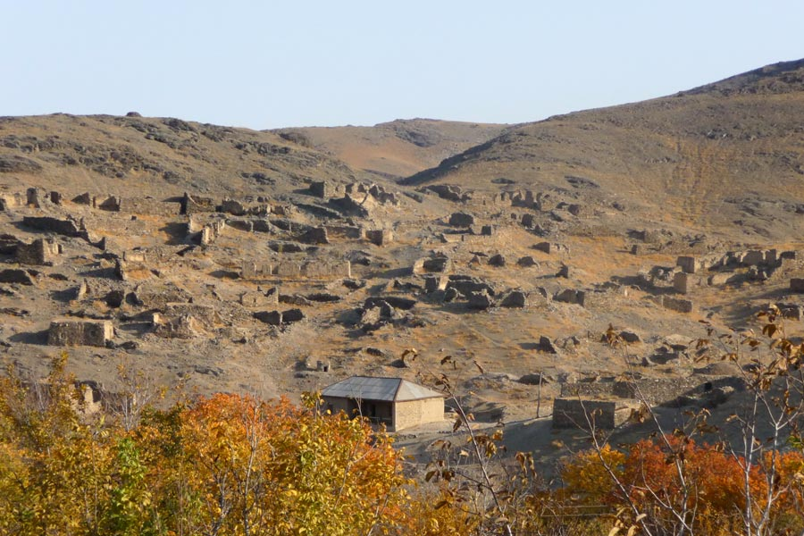
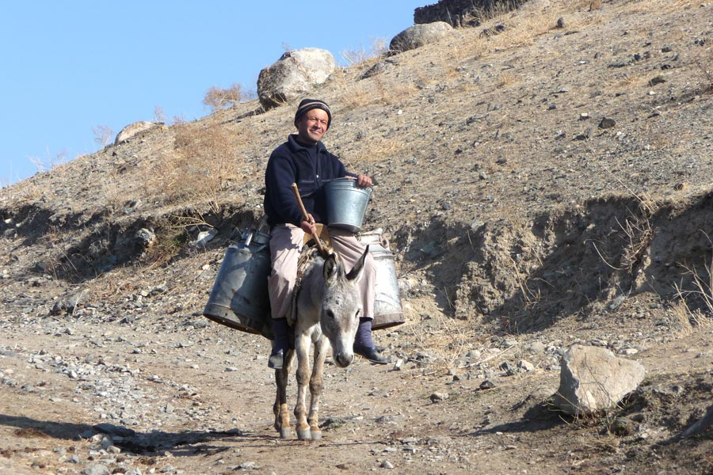
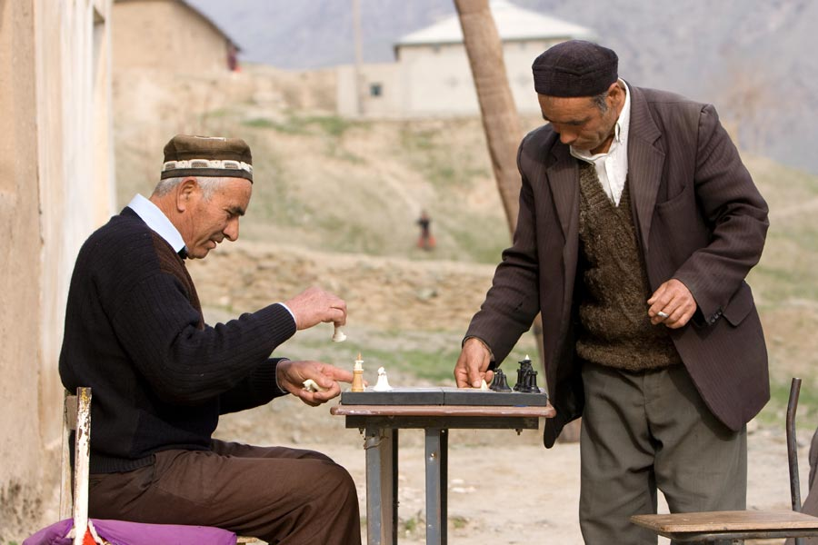

Your 3-Day Rural Homestay in Nuratau Mountain Villages Hayat
Day 1: Day 1: Bukhara – Nuratau Mountains (Hayat Village)
09:00 – Depart from Bukhara to the Nuratau Mountains12:00 – Stopover in Nurata and visit:The ruins of Alexander the Great’s fortressA local Suzani embroidery workshopChashma Mosque and its sacred spring
13:00 – Continue the journey to Hayat village (220 km / ~4 hours)
15:00 – Arrive in Hayat and check into the homestay
15:30 – Lunch at the homestay
16:30 – 18:00 – Walking tour around the village:Visit the breeding enclosure of wild Severtsov’s sheep, an endangered speciesExplore the ruins of an old settlement
18:00 – Dinner at the homestay
Overnight stay in Hayat homestay
Day 2: Day 2: Trekking from Hayat to Uhum village
After breakfast, meet your mountain guide and begin the hike to Uhum Village via Upper Ukhum (12 km / approx. 4 hours). From the mountain pass, enjoy panoramic views of the village below. In Upper Ukhum, see ancient irrigation channels still in use and visit a historic petroglyph site before returning to Hayat Village.
After lunch master class
Day 3: Day 3: Hayat villa ge – Samarkand
08:00 – Breakfast at the homestay09:00 – Depart from Hayat village towards Samarkand13:00 – Arrive in Samarkand
price tour 500 euro
2 x €250.00

